

**１１月２９日は、ぐんま・すききの日**

**には、おいしいがたくさんあるよ！**

**・こんにゃく・ねぎ・しいたけ・はくさい・など、すききのが　　でそろっちゃう！**

[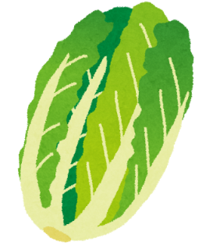](http://2.bp.blogspot.com/-7kSHbON57sE/UkJM4oCs9kI/AAAAAAAAYU4/wxHKVqDMs0E/s800/hakusai.png)

**はくさい**

**肉**

[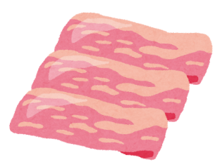](http://3.bp.blogspot.com/-3fiIVtk4S0o/U2srxNRIiHI/AAAAAAAAf34/uF3rqhHKHnE/s800/niku_buta.png)

[](http://2.bp.blogspot.com/-Kr1dcXLn7fk/Us_ML0YwSxI/AAAAAAAAdCM/PrhC7MN3ig0/s800/food_shirataki_itokonnyaku.png)

[](http://4.bp.blogspot.com/-ouxvqS-MNoI/UkJM7ra15rI/AAAAAAAAYVw/2zZKFSO09Hw/s800/negi_green_onion.png)

**しいたけ**

[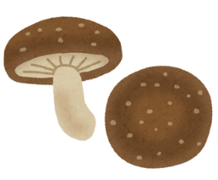](http://4.bp.blogspot.com/-BKS6qti9-Qo/UsZtLg5qjFI/AAAAAAAAcy4/VdPi_SZqTXM/s800/kinoko_shiitake.png)

**しらたき**

**ねぎ**

[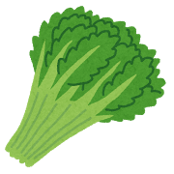](http://www.irasutoya.com/2015/01/blog-post_249.html)**[](http://www.irasutoya.com/2012/12/blog-post_7617.html)[](http://3.bp.blogspot.com/-QCe-ngfpbTg/UkJM8tkaq6I/AAAAAAAAYWM/U3pbo3YS9XA/s800/ninjin_carrot.png)[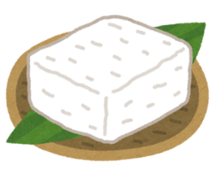](http://2.bp.blogspot.com/-dMEzDYX8OlU/VRUSDV5tf1I/AAAAAAAAslQ/6we0poh1YdM/s800/food_tofu_shimadoufu.png)**

**とうふ**

**しゅんぎく**

**たまねぎ**

**にんじん**